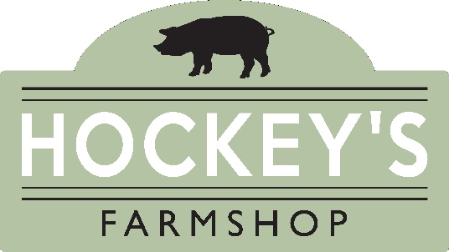

Christmas 2023 Butchery Price List
South Gorley, Fordingbridge, Hampshire, SP6 2PW
naturalmeats@hockeysfarm.co.uk 01425 652542
- Opening Times - Monday-Sunday - 9am-5pm,
Thursday 21st, Friday 22nd & Saturday 23rd – 8am-6pm,
Christmas Eve 8am-2pm, Closed Christmas Day and Boxing Day
Deposit required: £20 per order or £50 per Turkey or Goose

To avoid disappointment please place your order by Monday 11th December. Any orders taken after this date will be subject to availability.

Beef Price Per Kg
Sirloin £36.99kg
Fore-Rib of Beef (Bone-In) £26.99kg
Boned & Rolled Rib of Beef £29.99kg
Topside £17.99kg
Silverside £16.99kg
Brisket £15.99kg
Fillet £59.99kg

Lamb Price Per Kg
Free Range Leg of Lamb £16.99kg
Free Range Shoulder of Lamb £14.99kg

Poultry Price Per Kg
New Forest Turkey (White Hen) £21.99kg
New Forest Turkey (Bronze) £23.99kg
Boned & Rolled Turkey Breast £19.99kg
Boned, Rolled & Stuffed Turkey Breast £20.99kg
Free Range Goose £26.99kg
Free Range Chicken £12.99kg

Pork Price Per Kg
Boneless Leg of Pork £12.99kg
Boneless Spare-Rib of Pork £14.99kg
Boneless Loin of Pork £14.99kg
Bone-In Belly of Pork £12.99kg
Boned & Rolled Belly Pork £14.99kg

Venison & Game Price Per Kg
Boneless Haunch of Venison £19.99kg
Venison Loin £32.99kg
Venison Haunch Steaks £19.99kg
Diced Venison £15.99kg
Pheasant £8.00 Each
Brace of Pheasants £14.00 a Brace
Partridge £6.50 Each

Gammon, Bacon & Ham Price Per Kg
Boneless Green Gammon £12.99kg
Boneless Smoked Gammon £12.99kg

Green Back Bacon £21.99kg
Smoked Back Bacon £23.49kg
Green Streaky Bacon £21.99kg
Smoked Streaky Bacon £23.49kg

Traditionally Cooked Ham £24.99kg

Sausagemeat & Sausages Price Per Kg
Pork Sausagemeat £11.99kg
Pork Chipolatas £13.99kg
Pigs in Blankets £15.99kg
Gluten Free Available

Surname: | First Name: | Telephone Number: | Date of Collection:
Meat | Weight/Packs | Additional Information | Boneless  Please tick if appropriate | Bone-In  Please tick if appropriate

Christmas 2023 Order Form
South Gorley, Fordingbridge, Hampshire, SP6 2PW
naturalmeats@hockeysfarm.co.uk 01425 652542
- Opening Times - Monday-Sunday - 9am-5pm,
Thursday 21st, Friday 22nd & Saturday 23rd – 8am-6pm,
Christmas Eve 8am-2pm, Closed Christmas Day and Boxing Day
Deposit required: £20 per order or £50 per Turkey or Goose

To avoid disappointment please place your order by Monday 11th December. Any orders taken after this date will be subject to availability.

