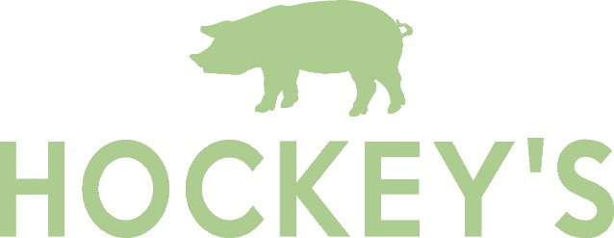

Welcome to Hockey’s Farmyard Café
We support local and family businesses
Chutneys and Jams from Tracklements in Wiltshire or Mrs Darlington’s in Cheshire.

Bread from Cowdry’s Dorset Family Bakery in Wimborne or Sourdough from BakeHouse24 in Ringwood.

Cakes baked locally at New Forest Cake House, Bakehouse24 or Berry’s Bakery.

Eggs from Fluffetts, ‘Clucking Good Eggs’ on the edge of the New Forest.

Burgers and Sausages are made here by our own butchers using Local Meat from our farmer friends.

Ham from Wessex Country Gammons in Wimborne.

Crisps come from Fairfields Farm Crisps in Essex.

All of which can be bought in our farm shop.

Hot food is served daily until 3pm.

Food is cooked to order so may take longer to arrive and is subject to availability.

Please inform your server if you have any allergies or intolerances before you order and please be aware that some ingredients may have change since you last visited us. Unfortunately it is not possible to guarantee that any product is free from any allergen due to the risk of cross contamination in our busy kitchen.
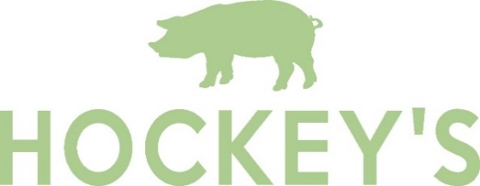

Toast - £4.00
2 Slices of White or Granary Toast, served with Butter & Jam or Marmalade

Hockey’s Breakfast Roll
Granary or White Roll to include…
The Original - Bacon or Sausage or Egg - £5.50,
The Double - 2 Fillings of Bacon, Sausage or Egg - £6.50,
Triple Whammy - 3 Fillings of Bacon, Sausage & Egg - £7.50

Vegetarian Breakfast - £12.95
2 Hash Browns, 2 Fluffetts Free Range Fried Eggs, Tomatoes, Mushrooms, Heinz Baked Beans, Toast & Tea or Coffee

Farmyard Breakfast - £12.95
2 Rashers of Cheshire Oak Bacon, 1 Hockey’s Pork Sausage, Fluffetts Free Range Fried Egg, Tomato, Mushrooms, Toast & Tea or Coffee

Hockey’s Vegetarian Hungry Breakfast - £14.50
2 Vegetarian Sausages, 2 Hash Browns, 2 Fluffetts Free Range Fried Eggs, Tomatoes, Mushrooms, Heinz Baked Beans, Toast & Tea or Coffee.

The Hockey’s Hungry Breakfast – £14.50
2 Rashers of Wiltshire Dry Cured Bacon, 2 Hockey’s Pork Sausages, 2 Hash Browns, 2 Fluffetts Free Range Fried Eggs, Heinz Baked Beans, Tomatoes, Mushrooms, Toast & Tea or Coffee.

All Day Breakfast Menu
Breakfast Extras may be added - £2.00

No Swaps but we can remove items for items for allergen reasons

Eggs on Toast - £6.50
2 Fluffetts Eggs – Fried or Scrambled on 2 Slices of White or Granary Toast

Beans on Toast - £6.50
Heinz Baked Beans on 2 Slices of White or Granary Toast

Hockey’s Beef Burger - £6.00
Served in a Brioche Bun with Crisps and Cucumber.

Children’s Platter - £6.50
Choice of Sandwich – Cheese, Ham or Jam, served with Crisps, Fruit, Sweet Treats & a carton of either Ribena or Cawston Drink.
.

A selection of Crisps, Biscuits, Fruit and Ice Creams are also available from the Farm Shop.

Children’s Lunch Menu
Sausage, Chips and Beans or Peas - £6.00
Hockey’s Sausage served with a portion of Chips with a portion of either Heinz Baked Beans or Garden Peas

Children’s Breakfast Menu
Mini Breakfast - £5.75
Fluffetts Free Range Fried Egg, Heinz Baked Beans, Cheshire Oak Bacon & Toast.

Beans on Toast - £4.50
A portion of Heinz Baked Beans with a slice of White or Granary Toast

Egg on Toast - £4.50
1 Fluffetts Egg – Fried or Scrambled with a slice of White or Granary Toast

Cheese on Toast - £4.50
1 slice of White or Granary Toast topped with Organic Cheddar Cheese

Lunchtime Menu
Served from 12pm onwards
Toasties - £11.50
Served with Coleslaw and either Salad or Chips
- Choose from -
Organic Cheddar Cheese and Wessex Ham
Wiltshire Dry Cured Bacon, Brie & Cranberry
Wiltshire Dry Cured Bacon & Organic Cheddar
Organic Cheddar Cheese & Tomato

Hockey’s Triple Stack Burger - £13
Our Own Handmade 3 x 2oz Beef Burgers served in a Brioche Bun, Bacon and Organic Cheddar Cheese with Coleslaw, Salad Garnish & Chips.

Laura’s Favourite - £11.50
Toasted Sourdough Slice topped with a layer of Red Onion Chutney and your choice of Cheese
- Choose From –
Organic Cheddar – Smoked Applewood – Blue Vinny
Served with Coleslaw and either Salad or Chips

Veggie Patch Burger - £12
Served in a Brioche Bun with Coleslaw, Salad Garnish & Chips.

Ploughman’s Platter - £12.50
Served with Wessex Ham and Organic Cheddar, Bread, Pickled Onions, Pickle, Coleslaw, Crisps, Salad & Apple.

Coffee
Americano
Cappuccino
Latte
Flat White
Espresso
Double Espresso
Mocha
Macciato
Iced Coffee

Children’s Hot Drinks
Child’s Hot Chocolate
Babyccino

Milk Options
Semi-Skimmed
Oat
Soya

Syrup Shot
Vanilla
Caramel
Tea
Dorset Tea
Earl Grey
Foraged Fruits
Wild About Mint
Pure Green Tea
Ginger & Sunshine Lemon

Hot Chocolate
Hot Chocolate
Deluxe Hot Chocolate
Drinks Menu
Afternoon Tea Menu
New Forest Cake House Scone - £3.75
Plain, Fruit or Cheese
Served with Butter
.

Hockey’s Farmhouse Cream Tea - £7.50
A locally baked Scone (Fruit or Plain), Dorset Clotted Cream, Mrs Darlington’s Strawberry Jam and a Pot of Dorset Tea.
(This can also be served with Coffee or a Cold Drink)
.

Hockey’s Stockman’s Savoury Tea - £7.50
A locally baked Cheese Scone served with a piece of Organic Cheddar, Chutney and a Pot of Dorset Tea.
(This can also be served with Coffee or a Cold Drink)
.

Cakes - £3.95
Selection of locally produced Traybakes and Cakes from
New Forest Cake House and Berry’s Bakery.
.

Please be aware all our Cakes and Scones are produced in a kitchen which also uses NUTS in their cooking.
.

Food Allergens and Intolerances – please ask staff for more advice
.

